ASSOCIATION VON HUMBOLDT SESSIONS
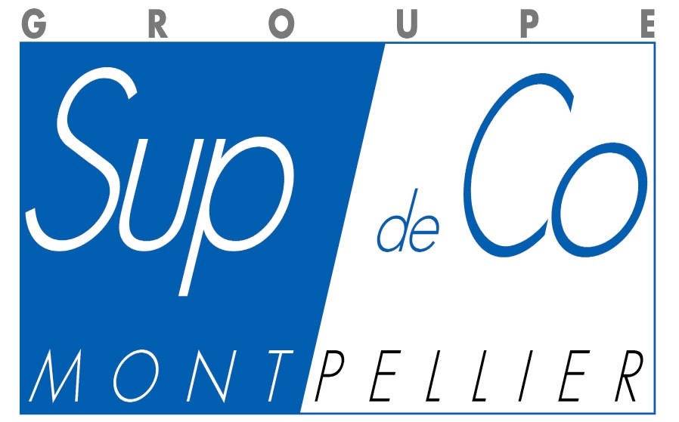

Academic exchanges between business administration schools

of the European Union and of Latin American countries

During the 41st CLADEA Annual Assembly that will be held from September 10th to September 13th 2006

In the Corum Convention Centre, Montpellier, France

Registration of interest and participation

The participation to the AVH sessions is free, but this registration can only be validated if you attend the Cladea Annual Meeting.

Name of institution:

Name/s of representative/s of institution:

Position:

Address:

Country:

Tel. (Including international dialling code):

Fax. (Including international dialling code):

Email:

□ Institution Member of AVH
□ Institution Member of Cladea
□ Partner of the Groupe Sup de Co Montpellier
□ Other institution

Would you like solely to be a participant in the sessions or would you like to present your institution along with its programmes?

Participant only Yes No Presentation of my institution Yes No

Please contact the following web page for your registration to Cladea: http://www.supdeco-montpellier.com/cladea2006/

For your participation to the AVH sessions, please send this registration form by fax: + 33 4 67 40 56 50 or by e-mail at: HAchouri@supco-montpellier.fr

